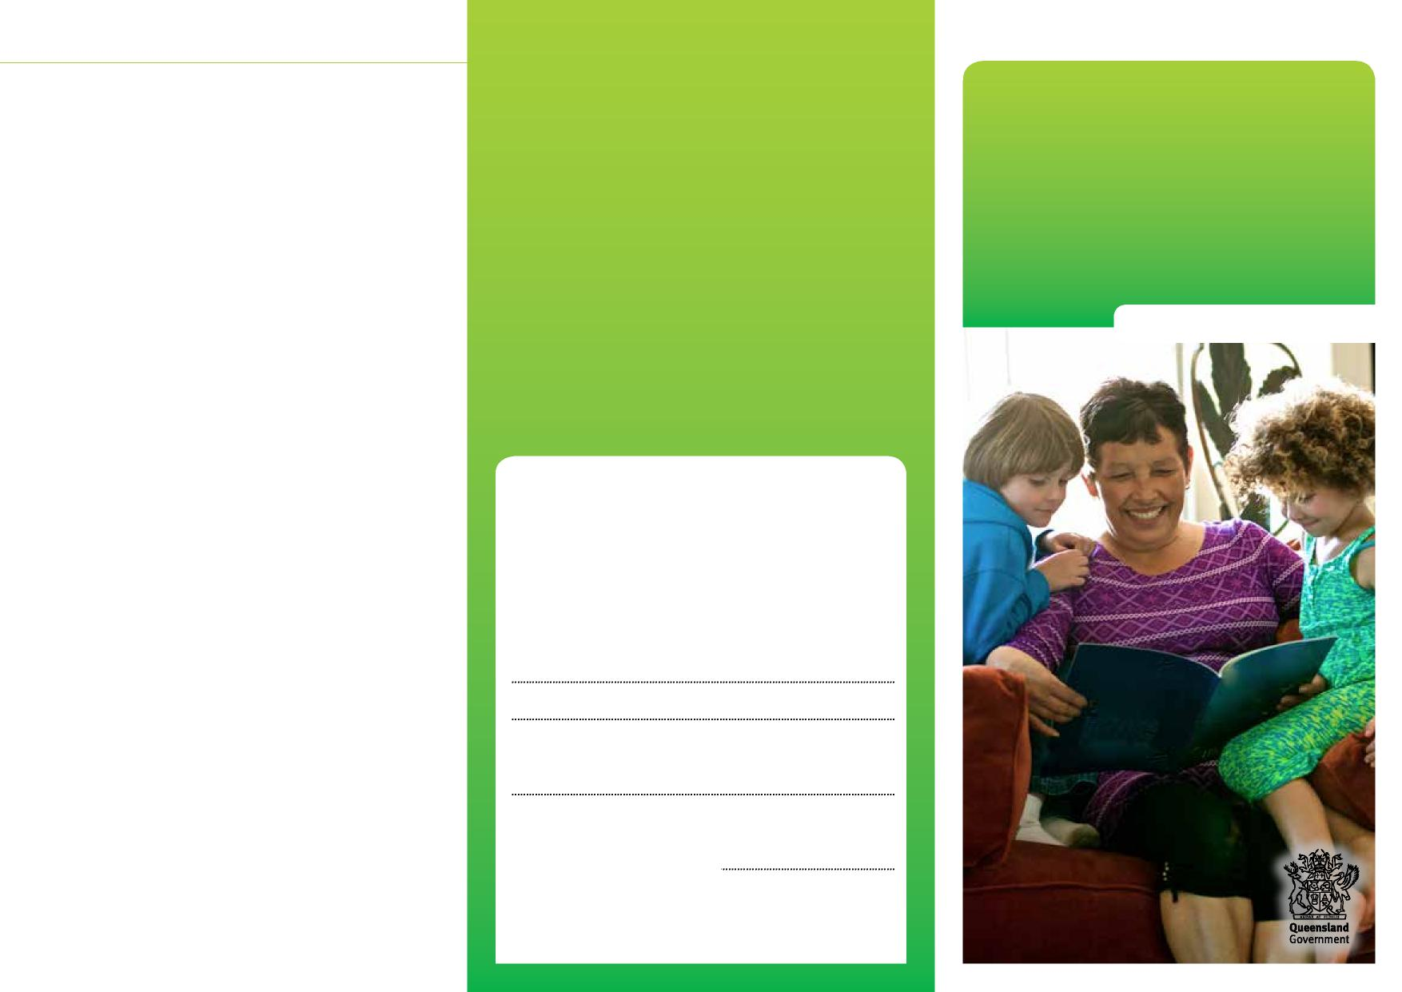
Care agreements Department of Children, Youth Justice and Multicultural Affairs
How does a care agreement end?
Care agreements
In most cases, the care agreement ends on the date we have both agreed to. A care agreement can also end if we, or you, give 2 days’ notice.
If your family situation changes, or if you want to end the care agreement, we’ll first need to assess if it’s safe for your child to return home.
For a child protection care agreement, if we assess that it’s not safe for your child to return home, we’ll talk to you about our worries and extending the agreement.
Information for parents
If you choose not to extend the child protection care agreement, we may apply for a temporary custody order from the Childrens Court, which would grant custody of your child to us. If this happens, the care agreement will end.
More information
We recognise that this may be a worrying time for you, and we want to work with you to do what’s best for your child. You can talk to us at any time about what’s happening.
Child Safety Officers:
Senior Team Leader:
Child Safety Service Centre:
Phone:
Child Safety After Hours Service Centre: Phone: 3235 9999 or freecall 1800 177 135
0959_JULY2022

Care agreements

Caring for children and keeping them safe and well is very important. Sometimes, parents need help to do this.
We work with families to help them protect and care for their children.
If we’re worried that your child is not safe living at home and you’re willing to let us help your family, we’ll talk to you about a care agreement.
What is a care agreement?
A care agreement is made when you agree for your child to be placed with an approved carer while we help you get the support you need.
There are two types of care agreements: Assessment care agreement
An assessment care agreement is made while we assess what’s happening in your family, if your child needs protection and how we can help you safely care for your child.
Under this agreement, your child will live with an approved carer for up to 30 days only.
During this time, you’ll continue to have custody and guardianship of your child and make most of the decisions about your child’s care.
Child protection care agreement
A child protection care agreement is made if we’ve assessed that your child is not safe living at home.
We’ll develop a case plan to help you work on the things that need to change while your child lives with someone else.
Under this agreement, your child will live with an approved carer for at least 30 days. It can be extended, if required (up to a maximum of 6 months in a 12 month period).
You can record the decisions you want to make for your child in the child protection care agreement, and you’ll be given a copy of the agreement.
During this time, you’ll continue to be your child’s guardian. We’ll have custody of your child and provide for their daily care.
We’ll always talk to you about any important decisions to be made about your child’s care.
Where does your child live during a care agreement?
Once the care agreement is in effect, your child must be placed with someone we have approved as a carer. This is so we can be sure your child will be safe and well cared for.
If you have a family member or friend that your child knows and is close to, we’ll talk to them about being assessed as a carer for your child.
If you don’t have anyone who can care for your child, we’ll arrange for your child to be placed with a foster carer.
We’ll give you the foster carer’s details, including their name, address and phone number.
Who can you talk to?
As child safety officers, we’re trained to help families who are having tough times. You can talk to us about your worries or ask for help.
You can also talk to a lawyer or a local community organisation for legal advice:
- Legal Aid Queensland
Phone: 1300 651 188
- Community Legal Centres Queensland Phone: 3392 0092
- The Aboriginal and Torres Strait Islander
Legal Service (Qld)
Freecall: 1800 012 255

